Biology 2120

Spring 2011

Midterm Exam #1

Name (printed):______________________________________________

This exam contains 13 pages, *plus the multiple choice bubble sheet*. Please verify that you have all pages.

1. Write your name on both this exam *and* on the bubble sheet (fill in the bubbles for your name)

2. Write the *color* of your exam paper on the top edge of the bubble sheet

3. Answer all questions, using only the space available for the drawings/short answer section (part II).

4. You have until 11:30 AM to finish the exam- to receive credit for taking the exam, your exam *must* be handed in at the front of class when the proctor announces that the examination period has ended.

5. As indicated in the course syllabus, cheating in this course is strictly forbidden. Anyone who cheats on this exam will receive an F in the course and be referred for disciplinary action. By signing your name below, you indicate that you understand, and agree to comply with, this policy.

Name (signed)_______________________________________________

Part I. Multiple Choice. Choose the single best answer to each question.

1. Why don’t prokaryotes have heterochromatin?

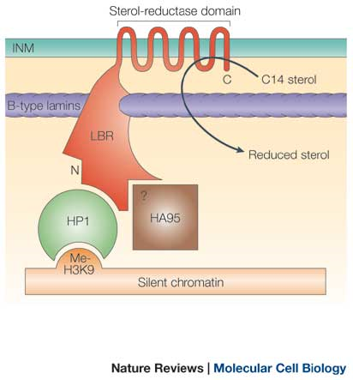A. Because they have fewer genes than eukaryotes.

B. Because they express all of their genes all of the time.

C. Because they store genetic information in RNA molecules rather than DNA molecules.

D. Because they don’t have centrosomes.

E. Because they divide faster than most eukaryotes.

2. Nuclear lamins are held to the inner nuclear membrane (INM) by receptors. Nuclear B-type laminins are bound by the lamin B receptor (LBR) illustrated in the diagram at the right. What else does this diagram tell you about the LBR?

A. It is an integral membrane protein.

B. It has seven domains.

C. It has nine different functional states.

D. It contains alpha helices but no beta sheets

E. It binds to B-type lamins at its carboxy terminus

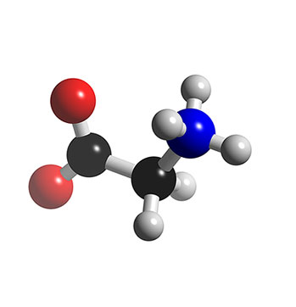The following three questions refer to the 3D model of the amino acid *glycine* in figure at left.

3. The arrow points to which atom?

A. Hydrogen

B. Phosphorus

C. Oxygen

D. Nitrogen

E. Carbon

4. Which statement about carbon is false?

A. It can form covalent bonds with four different atoms.

B. It can form hydrogen bonds with water.

C. It can form covalent bonds with other carbon atoms.

D. It can form covalent bonds with oxygen.

E. It can form covalent bonds with nitrogen.

5. Bacteria exist in our gut, despite the fact that one important function of our gut is to digest biological materials. Which statement best explains this fact?

A. These bacteria secrete proteinases that degrade digestive enzymes.

B. These bacteria synthesize proteins from D amino acids instead of the more common L amino acids.

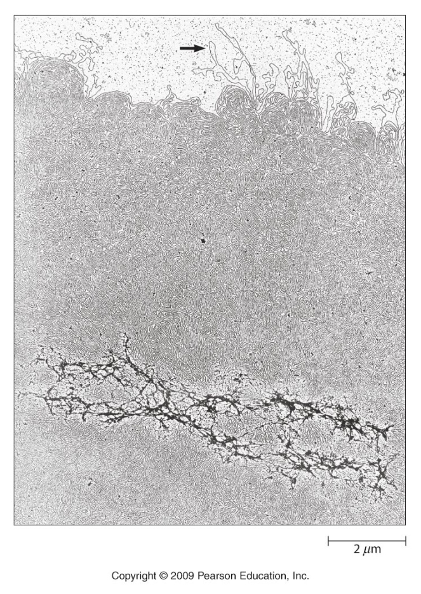C. These bacteria divide more rapidly than the proteinases can destroy them.

D. These bacteria are coated by a layer of beta 1,4 bonded polysaccharides.

E. These bacteria have less fluid membranes than human cells, preventing extracellular proteinases access to their internal contents.

6. Which statement below is best illustrated by the image at right (ignore the arrow)?

A. Detergents can dissolve the proteins that bundle DNA into compact, tightly wound chromosomes.

B. DNA in eukaryotes is double stranded, but single stranded in prokaryotes.

C. Bacterial DNA is circular and organized into structures called plasmids.

D. SDS denatures DNA molecules

E. The same DNA molecule can be wound into heterochromatin and euchromatin.

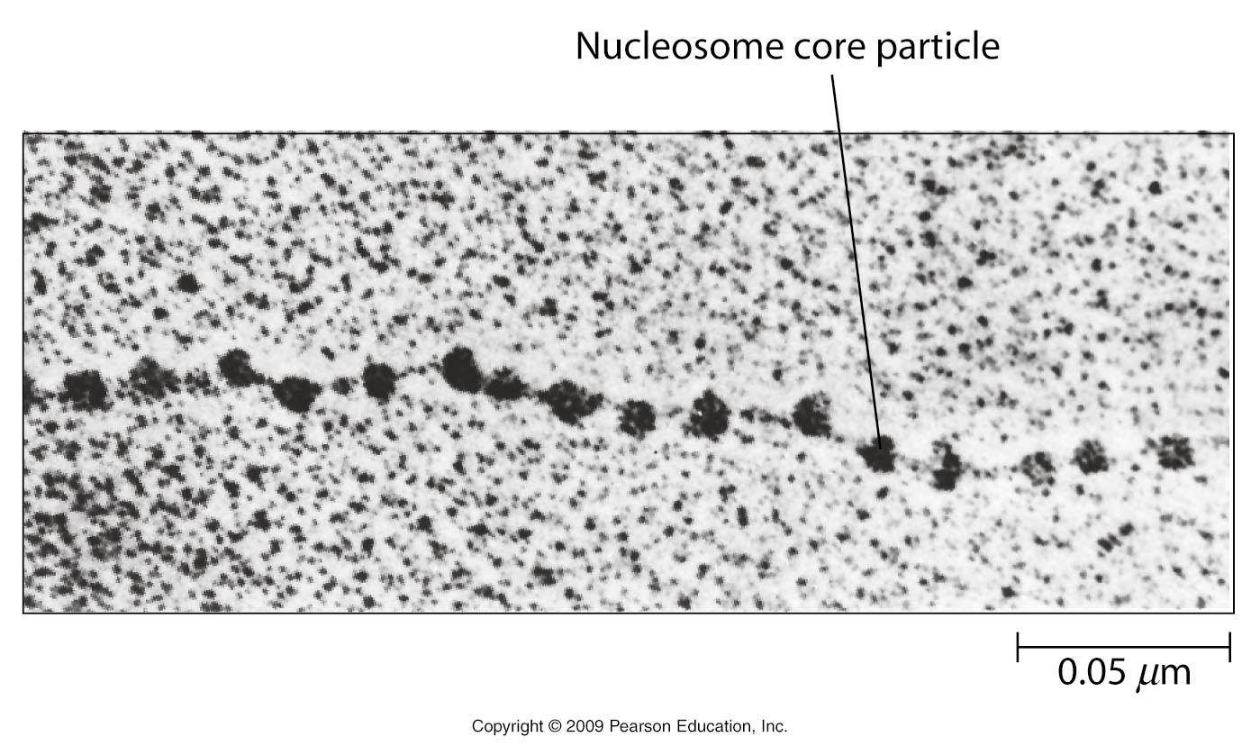7. Which statement best explains what the line in the picture at right is pointing to?

A. The line is pointing to ribosomes translating an mRNA molecule.

B. The line is pointing to nucleosomes that form along a double stranded DNA molecule.

C. The line is pointing to individual tubulin proteins in a microtubule.

D. The line is pointing to the head group on a single phospholipid.

E. The line is pointing to a globular domain in heterochromatin.

8. Can glycine form hydrogen bonds with other amino acids?

A. Yes, because it forms random coils between strands of beta sheets

B. No, because it is nonpolar.

C. Yes, because it is contains an alpha carbon.

D. No, because it does not form disulfide bonds.

E. Yes, because it contains a C=O bond and an N-H bond.

9. Imagine you perform the following experiment: you dissolve some cells in a solution containing SDS, centrifuge out the insoluble material, then split the supernatant into two tubes. You add a (extracellular) proteinase to one of these test tubes for 1 hr, then add the contents of each tube to adjacent wells in an SDS-PAGE gel. After you complete the electrophoresis, you stain the gel with Coomassie Blue solution, and examine the band pattern in each lane. What would you expect to see?

A. The lane containing the proteinase-treated sample will have a higher percentage of small proteins than the untreated sample.

B. The lane containing the proteinase-treated sample will look exactly like the untreated lane.

C. The lane containing the proteinase-treated sample will have a higher percentage of large proteins than the untreated sample.

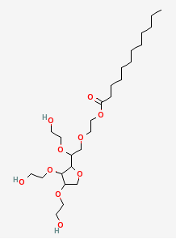D. The lane containing the proteinase-treated sample will have a higher percentage of membrane proteins than the untreated sample.

E. The lane containing the proteinase-treated sample will have a higher percentage of extracellular matrix proteins than the untreated sample.

10. Look at the diagram of the molecule at right. Based on your understanding of molecular structure, which statement do you feel best describes this molecule?

A. This is a phospholipid containing fully saturated fatty acids.

B. This a hydrophobic amino acid side chain.

C. This is an alpha1,4 linked disaccharide.

D. This is a nonionic detergent.

E. This a nonpolar amino acid.

11. The (approximate) wavelengths of visible light are shown in the table below.

|  |  |
| --- | --- |
| Violet | 400 nm |
| Indigo | 440 nm |
| Blue | 480 nm |
| Green | 540 nm |
| Yellow | 580 nm |
| Orange | 625 nm |
| Red | 725 nm |

Based on these values, what do you feel would be the best filter pair for visualizing Green Fluorescent Protein?

A. 400 nm excitation filter, 700 nm emission filter

B. 540 nm excitation filter, 570 nm emission filter

C. 450 nm excitation filter, 530 nm emission filter

D. 625 excitation filter, 540 nm emission filter

E. 700 excitation filter, 500 nm emission filter

12. Which statement best defines a *fusion protein*?

A. One that contains the amino acid sequences of two different polypeptides in one polypeptide.

B. One that contains both alpha helices and beta sheets.

C. One that can be visualized by both a phase contrast microscope and a fluorescence microscope.

D. One that can bind to more than one different target molecule.

E. One that can be recognized by antibodies from more than one species of animal.

13. What is the side chain (R group) on glycine?

A. -C=O

B. -N-H

C. –CH2-CH3

D. -H

E. -COOH

14. Do all polypeptides have tertiary structure?

A. Yes, because they all have secondary structures that occupy specific locations in 3D space.

B. No, because only proteins have tertiary structure.

C. Yes, because they all adopt at least two stable conformations.

D. No, because polypeptides are subunits of large protein complexes.

E. Yes, because they form domains.

15. If a proteasome digests cellular proteins, why doesn’t a cell always digest itself?

A. Proteins coated with sugars can’t be digested.

B. Proteins containing hydrophobic amino acids are always embedded in membranes.

C. The nucleus, which contains all essential information for building proteins, is protected by the two nuclear membranes.

D. The fluid mosaic model demonstrates that cells are composed of many additional molecules, including phospholipids, cholesterol, other lipids and nucleic acids.

E. Only proteins covalently attached to several ubiquitin proteins are degraded by proteasomes.

16. Look at the image on the screen. Which statement best describes how this image was generated?

A. GFP was transfected into cells, then the cells were photographed with a fluorescence microscope, using different filter sets to create different colors of GFP.

B. Unlabeled mouse primary antibodies against three different proteins were added to the cells, followed by one fluorescently tagged goat-anti-mouse antibody, then photographed by confocal fluorescence microscopy.

C. Phase contrast microscopy was used to generate a set of primary images; these were then given pseudocolors and merged to visualize different cellular proteins.

D. Three different primary antibodies from different species were added to the cells, followed by three different fluorescently tagged secondary antibodies from different species, then photographed with a fluorescence microscope, using different filter sets to create different colors.

E. A mixture of phase contrast, fluorescence, and electron microscope images were merged and colorized to indicate the position of different proteins.

17. How does Fluorescence Recovery After Photobleaching (FRAP) help demonstrate the fluidity of biological membranes?

A. It demonstrates that integrins bind to extracellular matrix proteins, and that these complexes are not fluid.

B. It demonstrates that phospholipids can include saturated or unsaturated acyl groups.

C. It demonstrates that phospholipids diffuse within the plane of a single face of a lipid bilayer.

D. It demonstrates that peripheral membrane proteins are only as fluid as the integrin membrane proteins they bind to.

E. It demonstrates that soap bubbles are more fluid than biological membranes.

18. Why does *ethanol* readily pass through phospholipid bilayers, while *sugars* (such as sucrose, which can be converted into ethanol) do not?

ETHANOL SUCROSE

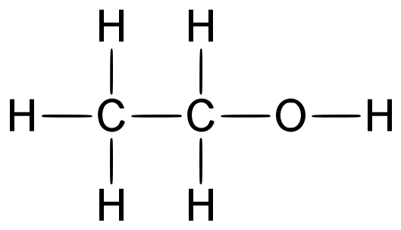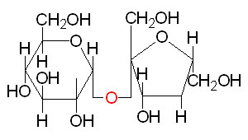

A. Sucrose is much more hydrophobic than ethanol.

B. Ethanol evaporates more rapidly than sucrose at room temperature.

C. Sucrose forms hydrogen bonds with water, but ethanol does not.

D. Ethanol is smaller than sucrose

E. Sucrose contains alpha1,4 glycosidic bonds, ethanol does not.

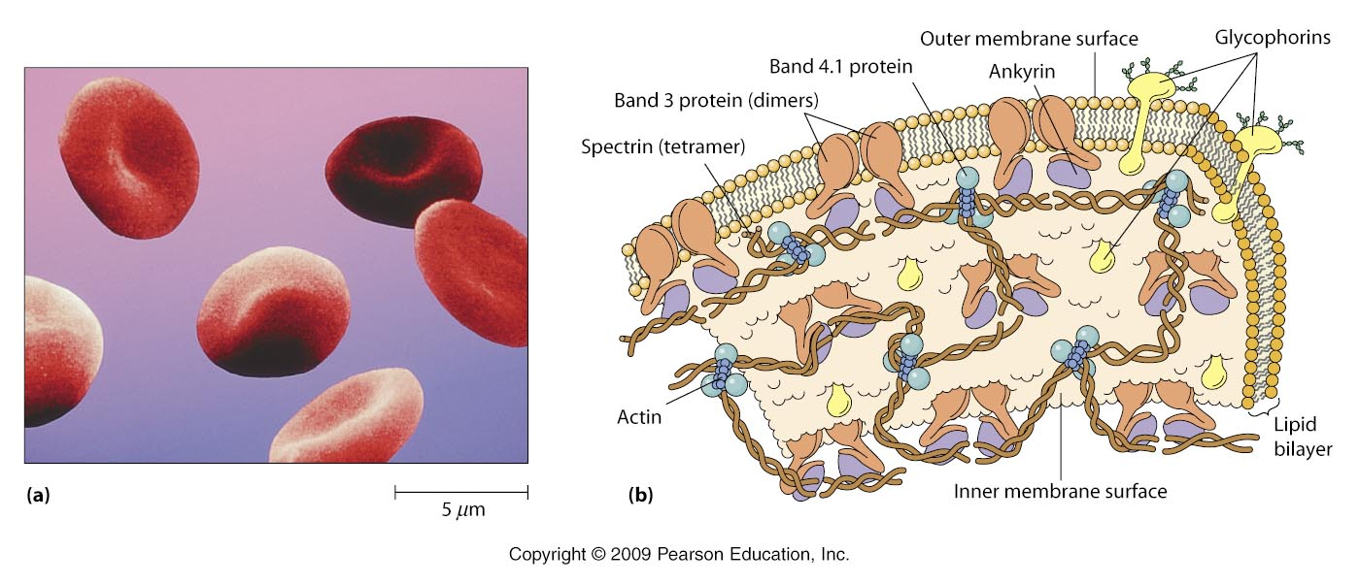

For the following two questions, focus on these proteins in the diagram of a red blood cell membrane, above:

i. Band 3 DON”T USE LETTERS< JUST NAME THEM

ii Glycophorins

iii. Spectrin

iv. Anykrin

19. Which protein(s) is/are most likely to possess at least one transmembrane alpha helix?

A. Spectrin and Ankyrin

B. Glycophorin

C. Band 3 and Spectrin

D. Glycophorin and Ankyrin

E. Band 4.1 and Actin

20. What is the likely impact on the fluidity of a phospholipid if its monounsaturated fatty acid is converted to a fully saturated fatty acid?

A. Fluidity will increase, because the volume of the phospholid decreases.

B. Fluidity will decrease, because the mass of the phospholipid increases.

C. Fluidity will increase, because the density of the phospholid increases.

D. Fluidity will decrease, because the hydrophobicity of the phospholipid decreases.

E. Fluidity will increase, because the volume of the phospholid increases.

21. (In Jeopardy® format) This extracellular protein contains both hydrophobic and hydrophilic domains and is capable of spontaneously refolding after it has been extended.

A. What is an integrin?

B. What is collagen?

C. What is an intermediate filament?

D. What is elastin?

E. What is a basement membrane?

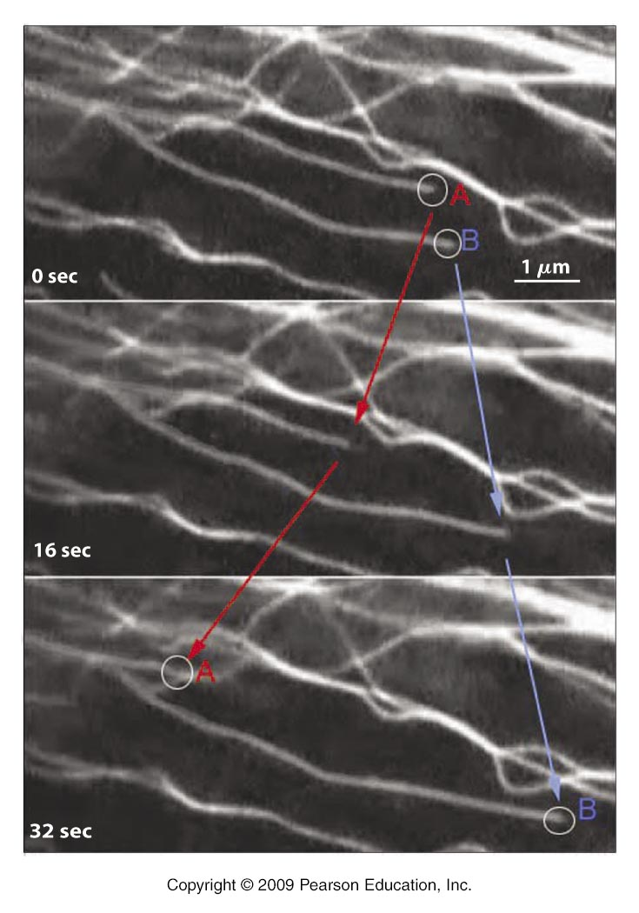22. What concept is best illustrated by the figure at left?

A. Nucleation of microtubules by γTuRC.

B. Treadmilling by actin filaments.

C. Dynamic instability of microtubules.

D. Loss of intermediate filaments in Epidermolysis Bullosa.

E. Myosin motors move towards the (+) end of microtubules.

23. What is the best explanation for why kinesin and dynein “walk” in opposite directions on microtubules?

A. Microtubules have structural polarity.

B. Kinesin binds to ATP, dynein binds to GTP

C. Conversion of ATP to GTP by dynein causes it to walk in the opposite direction.

D. Kinesin walks on growing microtubules, dynein walks on shrinking microtubules.

E. Microtubules grow when they bind GTP-tubulin, and shrink when they bind GDP.

24. What property do collagens, laminins, and nuclear lamins share?

A. They are extracellular matrix proteins.

B. They have coiled coils containing alpha helices.

C. They form hemidesmosomes.

D. They can be modified by adding phosphate groups to them.

E. They are integral membrane proteins.

25. What structural property makes proteoglycans distinct from all other extracellular matrix molecules?

A. They are polar and thus bind to water.

B. They are not found in basement membranes.

C. They contain no amino acids.

D. They do not bind to any other cellular molecules.

E. Their function is determined largely by the sugars they contain.

26. Which one of the following most accurately describes tight junctions?

A. They allow adjacent epithelial cells to control the passage molecules between them.

B. They bind to actin filaments and assist cells to crawl.

C. They permit cells to directly exchange small molecules with adjacent cells.

D. They allow adjacent cells to share tensile stress by linking their intermediate filament cytoskeletons.

E. They allow epithelial cells to contract their apical membrane domains.

27. What property of gap junctions makes them different from all other cell surface structures?

A. They contain transmembrane proteins.

B. They are found in the lateral membrane of epithelial cells.

C. They project into the extracellular space.

D. They contain proteins will alpha helices.

E. They form hollow channels that connect the cytosol of two cells together.

28. If cell biologists use the term “GTP cap” when discussing microtubules, why don’t they use the term “ATP cap” when discussing actin filaments?

A. ATP-bound actin monomers do not polymerize.

B. All actin monomers in an actin filament are bound to ATP.

C. Actin filaments do not undergo dynamic instability in cells.

D. Actin filament severing proteins cut the ATP cap off so quickly it is usually not detectable.

E. Actin biologists don’t consider depolymerization of an actin filament a catastrophe.

29. Which statement best describes a cadherin?

A. It is a transmembrane receptor in a hemidesmosome

B. It is a extracellular matrix protein in the basement membrane.

C. It is a transmembrane receptor in a cell-cell junction.

D. It is an integrin receptor in a focal adhesion

E. It is a transmembrane receptor in a gap junction.

30. Gelsolin is an actin filament severing protein. If you were to fluorescently label gelsolin in a migrating cell, where in the cell would it most likely be visible with a fluorescence microscope?

A. In the filopodia.

B. In the rear of the cell.

C. In the lamellopodia.

D. In the focal adhesions.

E. In the nucleus.

31. Which one of the following properties of actin filaments makes them different from other cytoskeletal proteins?

A. They have structural polarity.

B. They are enzymes.

C. They bind to motor proteins.

D. They routinely treadmill in cells.

E. They polymerize in a test tube.

32. This a verbatim quote from a real research grant proposal: “The hypothesis to be tested is whether the effect of Coronin 1B on actin mediated cell motility depends on its interaction with WISp39.” Is this a valid scientific hypothesis?

A. Yes, because it names specific proteins and a cellular function.

B. No, because it does not offer an explanation for how the named proteins control cell motility.

C. Yes, because it predicts that Coronin 1B interacts with WISp39.

D. No, because it cannot be tested.

E. Yes, because it adds new information about how cell motility is controlled.

33. If we immunoprecipitate a kinase protein to study its function, and use a primary antibody to capture it, what is the best way to release the kinase protein from the magnetic bead?

A. Add actin proteins to the beads, so they can replace the captured kinase proteins.

B. Boil the beads in physiological saline, so the increased heat will dislodge the kinase proteins.

C. Add more magnetic beads to the solution to bind any excess antibodies.

D. Add a secondary antibody to bind the beads.

E. Replace the initial buffer solution used to suspend the kinases with a buffer containing a slightly increased salt concentration.

34. Which statement about western blotting is **false**?

A. It reveals the primary structure of the target antibody.

B. It requires separation of proteins by SDS gel electrophoresis.

C. It requires transfer of proteins from a gel onto a membrane.

D. It cannot reveal the tertiary structure of a protein.

E. When used in combination with immunoprecipitation, it can detect a protein’s binding partners

35. Which protein(s) are classified as *peripheral membrane proteins*?

A. Ankyrin

B. Spectrin and Band 3

C. Glycophorin and Actin

D. Ankyrin and Glycophorin

E. Band 4.1 and Glycophorin

Part II. Drawings/short answer. Answer the questions in the space provided.

1. Using the table of amino acid side chains below, draw a dipeptide consisting of a non-polar amino acid at the amino terminus and a polar (*not ionic*) amino acid at the carboxy terminus (switch this around). Indicate all of the planar atoms in a peptide bond.

|  |  |  |  |  |
| --- | --- | --- | --- | --- |
| Serine | Alanine | Lysine | Cysteine | Aspartate |
| -CH2OH | -CH3 | -CH2-CH2-CH2-CH2-NH3+ | -CH2-SH | -CH2-COO**-** |

2. Draw a “generic” phospholipid, containing fully saturated fatty acids. Remember that single bonded carbon forms tetrahedral bonds, and use this information to show how saturated fatty acids form zig-zag patterns. You may use “H” as an abbreviation for the Head group. Show all other carbons, oxygens, hydrogens, etc. Assume that each fatty acid contains only six carbons (include the structure >C=O as the first carbon in the fatty acid).

3. Draw two nucleotides *in the middle of a DNA molecule*. You may use “…” to indicate additional nucleotides at either end of these two. Circle the 5’ carbon at one end of the pair, and the 3’ carbon at the other end.

4. Use the following guide to help you draw the overall structure (the names of specific proteins in these structures are not required) and proper location of the following structures in/near epithelial cells. Label your diagram completely.

A. Gap Junction

B. Tight Junction

C. Focal Adhesion

D. Centrosome

E. Hemidesmosome

F. Basement Membrane

(APICAL MEMBRANE AT TOP OF DIAGRAM)

5. Draw an antibody at the level of detail discussed in class. **Label your diagram completely**. Assuming this is a primary antibody for use in research, indicate with a circle where on the antibody you expect a commercial secondary antibody to bind.

SCORE: PART I________________ + PART II____________________ = ________________ out of 70 points total.